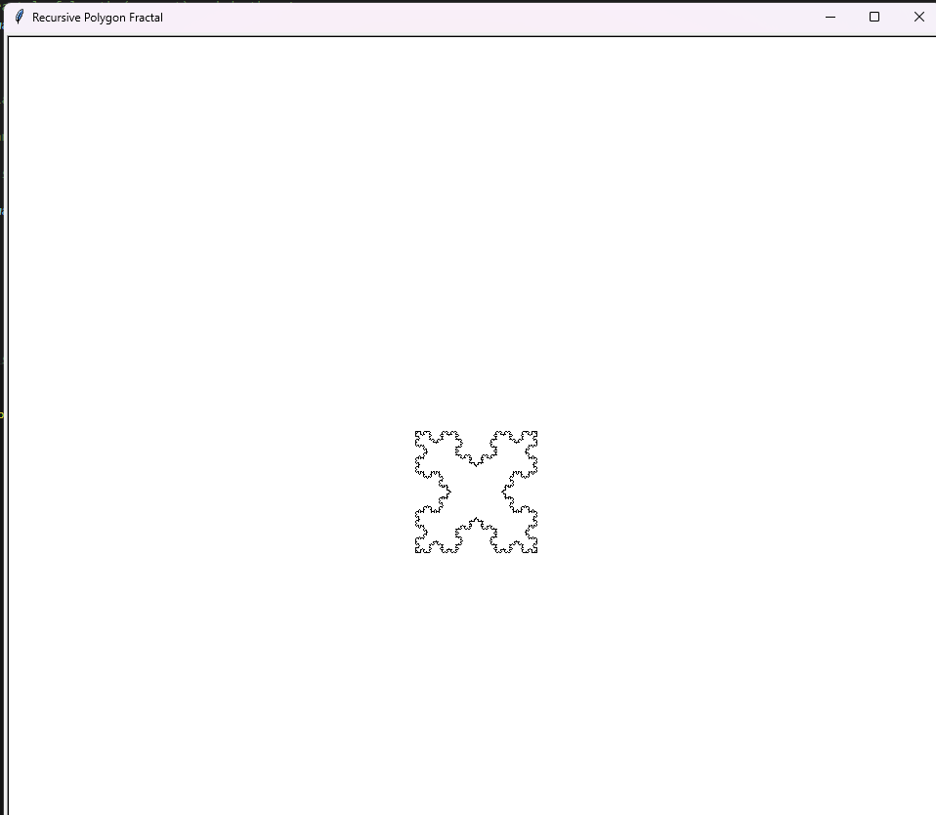
Picture 1: geometric pattern using Python's turtle graphics.
Question 3: Expected result.
Enter the number of sides: 4
Enter the side length (pixels): 124
Enter the recursion depth: 4

